**Client-Based VPN Tunneling Option for ODI**

Stratus Video offers secure VPN access using the Cisco AnyConnect Secure Mobility client. The client is easily installed in minutes on Windows 7 32-bit and 64-bit, Windows XP SP2+ 32-bit and 64-bit, Mac OS X 10.6 or later, and Apple iOS (iPad) operating systems. Stratus Video provides an SSL certificate for each client device. For tunneling. only outbound port 443 needs to be opened on customer’s firewall, pointing to our firewall IP addresses 74.119.12.20 and 74.119.14.20. AES-128 encryption meets HIPAA compliance for secure video and audio transmission. Since iOS and Windows are the most commonly deployed in hospital environments, download and installation instructions are outlined below.

**iOS (iPad or iPhone) AnyConnect Download and Installation:**

1) Open Safari, enter URL <https://profile.stratusvideo.com/download/>.  Click on "Install Stratus Provisioning Profile" link that appears on browser,  an Install Profile "Stratus VPN" window appears, click "Install", "Unverified Profile" popup appears, click "Install Now", StratusVPN window should now say "Profile Installed" at the top, click "Done".

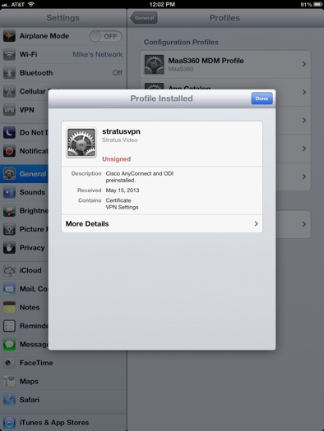

2) Go to the AppStore and download the Cisco AnyConnect app. Once it installs, click "Open" and the AnyConnect application will be auto-configured with the StratusVPN profile, including the SSL certification and all settings to auto-connect whenever ODI is logged into (iOS versions iOS 6.x only). The connection profile created is called "Stratus Video VPN" and is enabled as the default

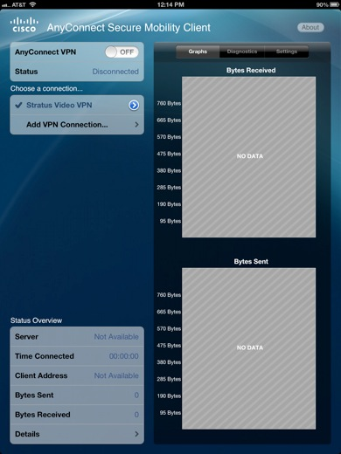

3) Slide the AnyConnect VPN “switch” to the “ON” position.  A "VPN" icon will appear in the upper left hand corner of the iPad, indicating that the AnyConnect AES128 VPN connection is established.

4) Go to the AppStore and download the Stratus Video ODI app.

5)  Open the ODI app and log in. The VPN must be enabled prior to logging into ODI.

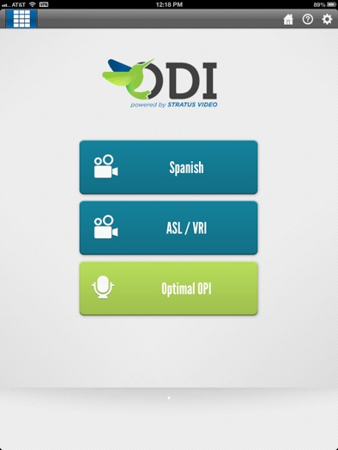

**Important:** With the new release of the iOS 7.x operating system for the iPad, some of the functionality of the AnyConnect VPN software has changed. In iOS 6.x, the AnyConnect VPN client will automatically connect the VPN once the Stratus Video ODI app is started. **However**, due to some changes in the way Apple handles on-demand VPN connections in iOS 7.x, this functionality is no longer available, so the VPN will need to be started manually prior to logging into the ODI app. This can be done by opening the AnyConnect Secure Mobility Center app on the iPad home screen, and sliding the AnyConnect VPN “switch” in the upper left of the AnyConnect Secure Mobility Client window to the ON position.

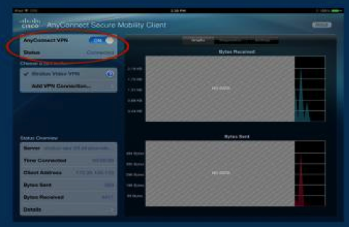

Close the AnyConnect Mobility Center and the “VPN” icon will be in the upper left hand corner of the iPad, indicating the VPN is on. You can now log into the ODI app.

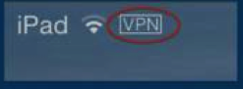

**Windows AnyConnect Download and Installation:**

1) Download and install the SSL certificate for the AnyConnect Windows client using this link <https://profile.stratusvideo.com/download/certs/stratusvpn.p12> The Windows certificate install wizard will open.  Follow the prompts to install the certificate. The password field should be left blank when prompted during the certificate installation.

 If the PC is running “PGP” encryption software, then you may have to import the certificate using the Windows Certificate Manger. To use the Certificate Manager, you must be logged in as an administrator. Click the Windows Start button, type **certmgr.msc** in the Search box, and press **ENTER**. (You may be prompted for an administrator password, which you would need to enter to proceed.) Click the **Personal** folder, then click the **Certificates** folder, then select the **vpnuser.stratusvideo.com** certificate. Click the **Action** menu, point to **All Tasks**, then click **Import**. Click **Next** and follow the instructions.

2)  Once you have installed the certificate, go to <https://stratus-asa-20.stratusvideo.com> and follow the prompts to download and install the Cisco AnyConnect software onto the laptop.  You will be prompted to confirm the certificate. Click OK. You will prompted to install the AnyConnect client. Click Download and follow prompt to install the AnyConnect software.

3)  Open the AnyConnect software and enter stratus-asa-20.stratusvideo.com in the "VPN" field and click on connect.  The VPN client should connect

4)  Log into the Stratus Video ODI video software client using the 10-digit account number provided by Stratus Video.  You will be able to click on a language option to be connected to the next available interpreter.

5) In order for AnyConnect to automatically start when Windows is started, please check the “Start VPN when AnyConnect is started” check box under the **Preferences** tab in the AnyConnect settings menu. The settings menu is accessed by clicking on the little “gear” icon in the lower left hand corner of the AnyConnect Secure Mobility Client application.

Also, you will need to check the Cisco Secure Mobility Client check box under the **Start Up** tab in the Windows System Configuration utility, and click **OK** to confirm the change. (The Configuration utility is opened by clicking the Windows Start button, enter **msconfig** in the Search box, and press **ENTER**.)

